Factsheet: Savanna fire management projects

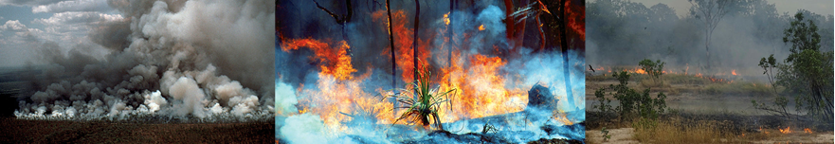
The benefits of running a savanna fire management project
Savanna fire management projects reduce the size, intensity and frequency of savanna wildfires in northern Australia to decrease the amount of greenhouse gases released into the atmosphere. This reduction in emissions earns Australian carbon credit units (carbon credits).
Undertaking controlled savanna burning has a range of other environmental, economic, social and cultural benefits:
Diversified revenue  Carbon credits provide an additional income stream for savanna land managers. | 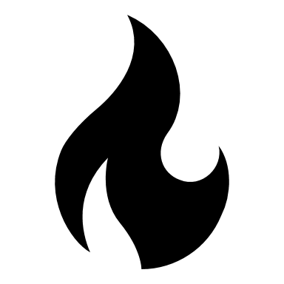  Cultural benefits  Indigenous savanna projects use traditional knowledge and provide on-country economic opportunities for Indigenous communities. | Farm benefits  Controlled burns improve pastoral productivity by stimulating grass regrowth and inhibiting woody weeds. | Property protection  Reduced wildfire intensity decreases threat to property, livestock and infrastructure.

How savanna fire management projects work
Savanna fire management projects involve strategic burning in northern Australia’s early dry season (January to July) to decrease the size, intensity and frequency of late dry season wildfires. The reduction in wildfire emissions earns carbon credits.
There are two types of savanna fire management projects: savanna emissions avoidance and savanna sequestration. Both types of projects earn carbon credits for reducing wildfire emissions through annual fire management practices. A savanna sequestration project also earns carbon credits for increasing the carbon stored in dead organic matter from fire management, which must be maintained for 25 or 100 years through continued fire management.
Emissions reductions are calculated for each calendar year using the free Savanna Burning Abatement Tool (SavBAT), which compares wildfire emissions both before and after your project started.

Savanna fire management project activities
Savanna fire management projects must undertake strategic early dry season burning every calendar year. This may be carried out by practices such as igniting fires from aircraft, from vehicles or by walking across country with handheld drip torches. Early dry season fire management may be supported by late dry season fire management activities such as constructing fire breaks. The type of fire management activities undertaken will depend on the local landscape and weather conditions.

How the Emissions Reduction Fund works
The Emissions Reduction Fund offers landholders, communities and businesses the opportunity to run new projects that reduce or remove greenhouse gas emissions from the atmosphere.
In running an Emissions Reduction Fund project, you can earn carbon credits and sell them to the Australian Government, or to companies and other private buyers. Each carbon credit represents one tonne of carbon dioxide equivalent greenhouse gas emissions stored or avoided.

How to participate
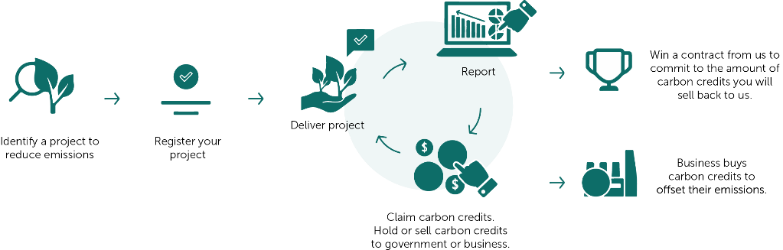
Emissions Reduction Fund project lifecycle

Make sure you are eligible to participate
To be eligible you must:
- Identify eligible project areas – land in your project must be in the high or low rainfall zone in northern Australia and contain appropriate savanna vegetation types. You cannot include areas that have gamba grass (a specified weed species).
- Establish legal right (the right to run your project and claim carbon credits) – for example, holding relevant land titles, partnering with Indigenous landholders, or having a signed agreement with other landholders to run a project on their land.
- Obtain regulatory approvals and consent from everyone with an eligible interest in the project land. Consent holders will vary. They may include banks, state governments (if the land is leased) or relevant native title bodies corporate.

Running and reporting on your project
As part of registering a project, you will need to describe your proposed activities, explain whether your project is occurring on native title or Indigenous land, state whether state and territory bodies have been notified, outline when your fire permits are required, and calculate your expected carbon credits.
There are operating, monitoring, reporting and audit obligations in running a savanna fire management project. You will need to report on your project at least once every two years (for emissions avoidance projects) or once every five years (for sequestration projects). You receive carbon credits each time you report emissions reductions over a period of 25 years.
Savanna sequestration projects must store carbon for 25 or 100 years to deliver a long-term benefit to the atmosphere (known as ‘permanence’).

Further information
Visit our website www.cleanenergyregulator.gov.au or contact us on 1300 553 542.

https://savbat.environment.gov.au/

