FORM

CER-Facilities-Statement
v1.0 25/09/2015
Statement of Activity Intent
under Carbon Credits (Carbon Farming Initiative – Facilities) Methodology Determination 2015

Purpose of this statement
This statement is required by the Clean Energy Regulator when registering a project as an Emissions Reduction Fund (ERF) project under the Carbon Credits (Carbon Farming Initiative) Act 2011 (the CFI Act), where the project is covered by the Carbon Credits (Carbon Farming Initiative – Facilities) Methodology Determination 2015 (the Facilities Method). This statement has to be provided to the Clean Energy Regulator when applying to register the project as an ERF project.
This statement of activity intent will provide a statement to the Clean Energy Regulator that at the time this statement is made, in the absence of a declaration of the project as an eligible offsets project, the project abatement activities that the applicant/participant for the project named in this statement intends to implement (or has implemented), would not be (or would not have been) implemented at the facility named in this statement, during the crediting period for the project.
This statement should be signed by an officer of the person with operational control over the facility covered by the project. It is important to note that the applicant/participant may not necessarily be the person with operational control over the facility, and the person with operational control may not necessarily be the National Greenhouse and Energy Reporting (NGER) controlling corporation of the facility.
Applicants can choose whether or not the officer signing the statement is the chief financial officer (CFO) or equivalent of the person with operational control over the facility covered by the project. Under subsection 26(2) of the Facilities Method, If this statement is signed by an officer other than the CFO, the total facility abatement for the facility will be capped at 100,000 tonnes carbon dioxide equivalent (t CO₂-e) for the NGER year.
A separate signed statement of activity intent is required for each facility covered by the project. It is recommended that a statement for each facility is signed by the CFO when it is provided with the application to register the ERF project.
If this statement, when first given to the Clean Energy Regulator, was signed by an officer of the person with operational control over the facility who was not that person’s CFO, it can be replaced by a subsequent statement, signed by the CFO.
The cap of 100,000 t CO₂-e for a particular NGER year (and for any subsequent NGER years) will not apply to the facility if this replacement statement as signed by the CFO is given to the Clean Energy Regulator before the project report for the project for the reporting period including that NGER year is submitted to the Clean Energy Regulator. However, this cap will apply to the facility for all NGER years that are included in project reports given to the Clean Energy Regulator prior to this statement being signed by the CFO.

Instructions for completing this statement
Please read each part of this statement carefully, fully answer all the questions, sign where indicated, and attach the required documentation.
You must complete and submit:
- Part A: Statement of Activity Intent
You can choose to complete this statement by:
- printing the statement and filling it in by hand, or
- saving the statement and filling in an electronic copy.
Note that if you choose the second option, there may be times when you will need to print certain sections in order to sign them or in order to complete multiple entries for a single set of questions. These sections may be scanned back into the computer and submitted electronically with the rest of the statement.
Pen colours | Please use a black or blue pen to write on the statement.
Check boxes | Mark boxes like this with a ✔ or ✘. When an instruction asks you to ‘tick’ the box, you can still use either ✔ or ✘.

Help filling in this statement
Guidance for filling in this statement is available on the Clean Energy Regulator website.
If you require assistance or have any questions regarding this statement, please contact the Clean Energy Regulator general enquiries line on 1300 553 542 or email CER-ERFadministrators@cleanenergyregulator.gov.au.

Submitting this statement
A signed copy of this statement should be kept for your records.
You must submit a signed statement of activity intent with your project application.

By uploading to your ERF Project Application
You must upload the signed statement of activity intent to your ERF Project Application within the Clean Energy Regulator Client Portal. Ensure that you complete the Project details section of the application before you upload the signed statement.
Use the following the steps and illustrations for guidance on how to upload the signed statement to your application.
- Click the Eligibility details tab on the left side of your application.
- Go to the Describe the project and activities question.
- Click the attachment button on the right of this question.
- A pop up box will appear. Click on Select file to upload the signed statement of activity intent.
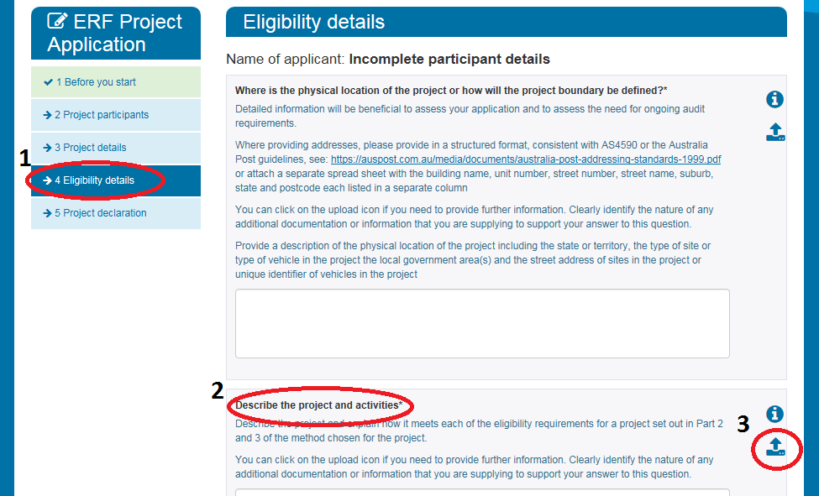
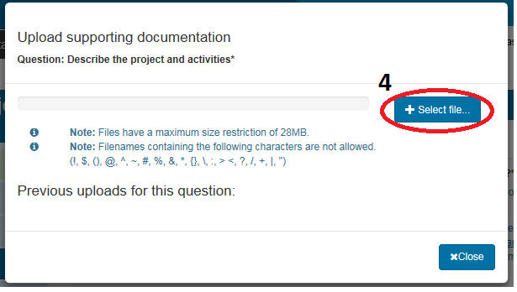

If a statement of activity intent was not signed by the CFO when provided with the project’s application, you may submit another statement of activity intent signed by a CFO after project application:

By post
Post your signed statement to:
ERF Applications
Clean Energy Regulator
GPO Box 621
Canberra ACT 2601

By email (preferred)
Alternatively, email your scanned, signed statement to the Clean Energy Regulator at
CER-ERFadministrators@cleanenergyregulator.gov.au.
Provide your ERF Project ID, project name and ‘statement of activity intent’ in the subject line of the email.
If you submit your signed statement by email, you do not need to send the original hardcopy of the signed statement by post. However, you should retain the original signed statement in your records for any potential audit requirements.
Office use:
- Statement of Activity Intent
This statement is made in accordance with the requirements of the Carbon Credits (Carbon Farming Initiative) Act 2011 and the Carbon Credits (Carbon Farming Initiative – Facilities) Methodology Determination 2015.
I, the undersigned and being an authorised representative of the person with operational control over the facility named below, certify:
I have read and understood the guidance referred to in this form and made available on the Clean Energy Regulator website.
I have made all reasonable inquiries, including of relevant officers of the applicant/participant named below to ensure that nothing in this form or statement is false or misleading or omits any material fact or information.
That all project abatement activities that the applicant/participant named below intends to implement (or has implemented) for the project named below at the time this statement is made, would not be (or would not have been) implemented at the facility during the crediting period for the project in the absence of a declaration of the project as an eligible offsets project.
I further certify that (tick one of the following):
I am the chief financial officer of the person that has operational control over the facility named below.
I am an officer of the person that has operational control over the facility named below but I am not the chief financial officer of that person.
Complete the following:
Facility name*
Project name
Applicant/participant name
Person
(has operational control over the facility named above)
*The facility name provided here must be the name of the facility described, and match the facility name provided, in the application to register the project named above as an Emissions Reduction Fund project.

If relevant provide the identifying details of the person that has operational control over the facility named above:
- If the person is a body corporate you must provide one of the following identifying details in order of precedence: ABN, ACN, ARBN or trading name and street address.
- Provide details of your ABN.
ABN
- If you do not have an ABN, please provide details of your ACN.
ACN
- If you do not have an ACN, please provide details of your ARBN.
ARBN

By signing below, the signatory:
- declares that the information supplied in this statement is true and correct and that he/she is authorised to make this statement as a representative of the person that has operational control over the facility named above; and
- acknowledges that giving false or misleading information is a serious offence and carries penalties under the Criminal Code.
Signatory name
Signature
Position
Organisation
Phone number | ( )
Email address
Signature date | Y | Y | Y | Y | M | M | D | D

- Additional information

Definitions
For the purposes of this statement:
applicant | means the participant of the project named in this statement prior to declaration of the project as an eligible offsets project.
chief financial officer | of a person who has operational control over a facility named in this statement, means:  - if the person is a body corporate—the chief financial officer (however described) of the body corporate; or  - otherwise—the individual who is primarily responsible for financial matters in relation to the person.
CFI Act | means the Carbon Credits (Carbon Farming Initiative) Act 2011.
controlling corporation | has the same meaning as in the NGER Act. In some cases, the controlling corporation might also be the applicant/participant or the person with operational control of the facility named in this statement.
crediting period | has the same meaning as in the CFI Act.
Facilities Method | means the Carbon Credits (Carbon Farming Initiative – Facilities) Methodology Determination 2015.
facility | has the same meaning as in the NGER Act.
NGER Act | means the National Greenhouse and Energy Reporting Act 2007.
NGER year | means a financial year from 1 July to 30 June the following year (e.g. 1 July 2015 to 30 June 2016 is the 2015-16 NGER year).
officer | of a person who has operational control over a facility named in this statement, means:  - if the person is an individual—the individual; or  - otherwise—an individual who:  - makes, or participates in making, decisions that affect the whole, or a substantial part, of the business or affairs of the person; or  - has the capacity to affect significantly the person’s financial standing.
operational control | has the same meaning as in the NGER Act.
participant | means the person that is responsible for, and has the legal right to, carry out the project named in this statement.
person | has the same meaning as in the Facilities Method.
project | has the same meaning as in the CFI Act.
project abatement activity | has the same meaning as in the Facilities Method.
project report | means documentation submitted by the participant for a project to report on the abatement achieved for a specified period.
total facility abatement | means the number worked out in accordance with section 26 of the Facilities Method.

Protection of information
The Clean Energy Regulator is bound by the secrecy provisions in Part 3 of the Clean Energy Regulator Act 2011 and by the Privacy Act 1988.

Privacy statement
'Personal information' is defined in the Privacy Act 1988 to mean information or an opinion about an identified individual, or an individual who is reasonably identifiable:
(a) whether the information or opinion is true or not; and
(b) whether the information or opinion is recorded in a material form or not.
The collection of personal information relating to this application is authorised by the Carbon Credits (Carbon Farming Initiative) Act 2011 (CFI Act), the Carbon Credits (Carbon Farming Initiative) Regulations 2011, the Carbon Credits (Carbon Farming Initiative) Rule 2015 and the Carbon Credits (Carbon Farming Initiative- Facilities) Methodology Determination 2015.
Personal information collected in relation to this application will be used for the purposes of assessing the application, auditing compliance, enforcement of relevant laws, regulations and legislative rules, the performance of our statutory functions and for related purposes. We will also use the personal information which you provide for our administrative purposes, for example, to pre-populate other Clean Energy Regulator forms which you wish to fill out online in the future, and for improving our service delivery to you. We cannot process the application if we do not collect relevant personal information.
The Clean Energy Regulator’s Privacy Policy contains information about the agency’s procedures for handling personal information including how a person can access their personal information held by the agency, and how to seek correction of such information. The Privacy Policy also contains information about how to complain about a breach of the Australian Privacy Principles.
The Clean Energy Regulator’s Privacy Policy can be found at the Clean Energy Regulator website.

Disclosure of information
The Clean Energy Regulator is only able to disclose information relating to this application (including personal information) in accordance with the CER Act, the Privacy Act 1988 or as otherwise required by law.
The circumstances in which such information may be disclosed include:
- Disclosure to other agencies, persons or organisations to enable the verification of information contained in the application;
- Disclosure to the Secretary or authorised officer of a Department for the purpose of administering a program or collecting statistics relating to greenhouse gas emissions, energy consumption or energy production;
- Disclosure to certain agencies, bodies or persons where the Regulator is satisfied that disclosure will enable or assist those agencies, bodies or persons to perform or exercise their functions or powers, including the Australian Securities and Investments Commission, the Australian Competition and Consumer Commission and the Commissioner of Taxation;
- Disclosure for the purposes of law enforcement;
- Disclosure for the purposes of a climate change law or for the purposes of the performance of our functions under a climate change law; and
- Disclosure where consent has been provided for the disclosure.

Accessibility disclaimer
The Clean Energy Regulator has worked to ensure that this document is accessible but please contact us to obtain an alternative version if you are having difficulty or you have specific accessibility needs. Please call 1300 553 542 or email the name of the statement and your needs to CER-ERFadministrators@cleanenergyregulator.gov.au.

