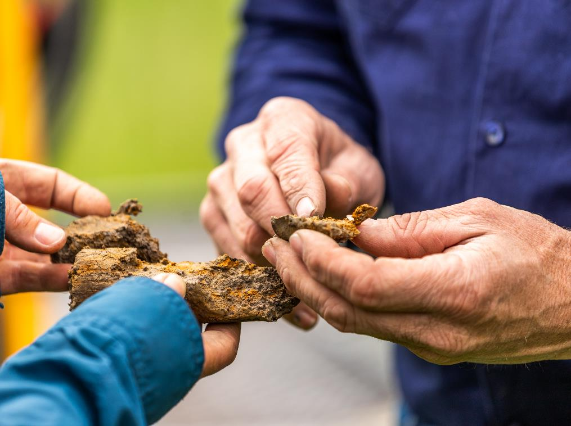
Safeguard Mechanism
Emissions-intensity audit report template
v1.1 – 26 February 2024

Contents
Emissions-intensity audit report template 3
Type of audit 5
Key risk area guidance 6
Safeguard Mechanism audit report for an emissions-intensity determination application 8
Audit report coversheet 8
Audited body (the applicant) 8
Audit description 8
Auditor details 9
Peer reviewer details 10
Part A — Auditor’s report 11
Details of audited body 12
Responsibility of [audited body’s] management 15
Our independence and quality control 15
Our responsibility 15
Summary of procedures undertaken 16
Use of our reasonable assurance engagement report 16
Inherent limitations 16
Our conclusion 16
Reasonable assurance conclusion 17
Limited assurance conclusion 17
Part B — Detailed findings 18
Items or issues requiring particular attention 18
Aspects that particularly impacted on carrying out of assurance engagement 18
Details of any contraventions of the National Greenhouse and Energy Reporting (Safeguard Mechanism) Rule 2015, National Greenhouse and Energy Reporting Act 2007, National Greenhouse and Energy Reporting Regulations 2008, National Greenhouse and Energy Reporting (Audit) Determination 2009 or the associated provisions 18
Matters corrected during the course of the audit 18
Other matters 18
Audit findings and conclusions table 19
Peer reviewer conclusion 19

Emissions-intensity audit report template
This template sets out how the Clean Energy Regulator (CER) expects an assurance engagement report to be structured for an audit of an application for an emissions-intensity determination under the Safeguard Mechanism. It is not mandatory to follow this template, but it is recommended.
It is the responsibility of auditors to ensure their audit reports meet legislative requirements.
Where text is included within brackets, for example [audited body], information must be provided in line with the suggested text.
Some parts of the templates are conditional on whether the application for an emissions-intensity determination includes certain information. These parts are marked in brackets as [Delete if not applicable]. The auditor will need to ensure that the audit report includes all specified information.
The audit must be conducted in accordance with the relevant requirements for assurance engagements under:
- ASQC 1 Quality Control for Firms that Perform Audits and Reviews of Financial Reports and Other Financial Information, and Other Assurance Engagements
- the National Greenhouse and Energy Reporting (Audit) Determination 2009 (NGER Audit Determination)
- relevant national and international audit standards, including:
  - ASAE 3000 Assurance Engagements Other than Audits of Reviews of Historical Financial Information
  - ASAE 3100 Compliance Engagements
  - ASAE 3410 Assurance Engagements on Greenhouse Gas Statements
- Please note, only some components of ASAE 3410 will be relevant. Auditors should use these standards as guidance.
This coversheet requires auditors to disclose both audit and non-audit fees, as well as the hours spent on the audit by the audit team. Please refer to 5.7.1 of the Audit determination handbook for more information on fee disclosure.
Refer to Division 3.4 of the NGER Audit Determination for further information on the legislative requirements for reporting an assurance engagement.
Main features of Safeguard Mechanism audits
The table below outlines the main features of audits under the Safeguard Mechanism.
Legislation or guidance | National Greenhouse and Energy Reporting (Safeguard Mechanism) Rule 2015 (the Safeguard Rule)  National Greenhouse and Energy Reporting Act 2007 (NGER Act)  National Greenhouse and Energy Reporting Regulations 2008 (NGER Regulations)  National Greenhouse and Energy Reporting (Audit) Determination 2009 (Audit Determination)  Applicable standards:  - ASAE 3000 Assurance Engagements other than Audits or Reviews of Historical Financial Information  - ASAE 3100 Compliance Engagements  - ASAE 3450 Assurance Engagements involving Corporate Fundraisings and/or Prospective Financial Information  - ASQM 1 Quality management for Firms that Perform Audits and Reviews of Financial Reports and Other Financial Information, and Other Assurance Engagements  - ASQM 2 Engagement quality reviews
Nature of engagement | Reasonable assurance and/or limited assurance engagement conducted over emissions-intensity determination application in accordance with the Safeguard Rule and Audit Determination.
Assurance practitioner | The audit team leader must be a Category 2 registered greenhouse and energy auditor.  Other members of the audit team do not need to be registered. However, the NGER Regulations do contain requirements for other members of an audit team.

Type of audit
 | Subject matter | Criteria
Emissions-intensity determination audits | The matters to be audited are whether, in all material respects:  Reasonable assurance matters  - the application correctly specifies the historical production variables (if any) for the facility;  - if the application includes the designated historical information about a historical production variable for the facility for a historical financial year— the application correctly specifies the quantity of the historical production variable in the historical financial year;  - the application correctly specifies the amount of covered emissions for the facility in each historical financial year; and  - the application correctly specifies the transitional production variables (if any) for the facility.  Limited assurance matters  - if the application specifies one or more historical production variables for the facility—the application correctly specifies the amount of covered emissions of greenhouse gases from the operation of the facility that are relevantly associated with each of those production variables;  - calculations of amounts of covered emissions of greenhouse gases from the operation of the facility that are included in the application meet the requirements specified in section 15 of the Safeguard Rule; and  - if the application includes estimates and assumptions made in accordance with subsection 15(3) of the Safeguard Rule —whether, in all material respects, those estimates and assumptions are reasonable.  - Please see the Safeguard Mechanism - Emissions-intensity determination guideline (v1.1) for clarification regarding the reasonable and limited assurance matters relating to facility covered emissions.  Previously audited matters  Despite subsections 3 and 4 of the Safeguard Rule (summarised above), the audit report does not need to include a conclusion:  - about a matter in subsection (3) if the responsible emitter has previously given the CER an audit report that includes a reasonable assurance conclusion in relation to the matter; or  - about a matter in subsection (4) if the responsible emitter has previously given the CER an audit report that includes a limited assurance conclusion in relation to the matter.  Please see Safeguard Mechanism - Emissions-intensity determination guideline (v.1.1) for information on the use of previous audit reports. | Section 17 of the Safeguard Rule.

Key risk area guidance
The table below sets out the key risk areas that the CER expects auditors will consider as part of their audit of an emissions-intensity determination application. The table does not provide an exhaustive listing of risks auditors are expected to address. It focuses on what the CER believes are key risks that should be addressed as part of audit procedures.
The CER expects auditors to use their professional judgement in determining what risks they are to address in conducting audits and what procedures they will conduct to address these risks. This may entail auditors addressing risks not included in this and other guidance from the CER.
Key Risk Area | Description
Exclusion of historical production variable and covered emissions data | It is expected that auditors will query whether or not historical data (i.e. production and covered emissions) has been excluded and whether it was because it was genuinely not reasonably practicable to provide that information.  The explanation as to why historical information has been excluded is required in the application and the CER expects auditors to be satisfied that this explanation reflects the information provided to them.  If historical data has been excluded and the CER doesn’t consider the explanation for exclusion as reasonable this may require resubmission of an application with additional auditing.  Please see Safeguard Mechanism - Emissions-intensity determination guideline for guidance on what the CER may consider as genuine reasons to exclude information.
Calculation of historical covered emissions | Auditors need to ensure that historical covered emissions has been calculated in accordance with section 15 of the Safeguard Rule, which requires historical covered emissions to be calculated using:  - the most recent version of the NGER Measurement Determination  - the most up-to-date global warming potentials (GWP) in the NGER Regulations  - the same method (that is, method 1, 2, 3, or 4) of calculating covered emissions as in the most recent NGER Report submitted for the facility.
Estimates and assumptions relating to calculating historical covered emissions | The CER expects that applicants carry out calculations of historical covered emissions to the highest degree of detail and accuracy that is practical.  If the required data is available to make the required calculation, that data must be used, and alternate adjustments relying on estimates and assumptions are not acceptable.  Where estimates and assumptions have been made, the application should explain the estimates and assumptions made and why they were required and reasonable.  Please see Safeguard Mechanism - Emissions-intensity determination guideline for guidance on what the CER considers as reasonable and not reasonable estimates and assumptions.
Apportioning of covered emissions to production variables | It is expected that auditors will consider the following higher risk circumstances:  - where a facility is using a large number of production variables as part of a complex facility e.g. oil and gas industry facilities.  - where the legislation is not prescriptive as to what production variable(s) an emission source(s) should be attributed to.
Covered emissions (facility and production variable level) and production quantity totals | Auditors need to ensure that the facility structure is consistent across the historical period of 2017-18 to 2022-23.  If a facility has restructured since the 2017-18 financial year, submitted data should align with the current facility structure. For example, if part of the facility was split-off and sold, the historical data associated with the sold portion does not need to be included in the application. This will ensure that facility specific emissions-intensity values are set consistently with the current facility structure.

Safeguard Mechanism audit report for an emissions-intensity determination application

Audit report coversheet

Audited body (the applicant)
Name of audited body
ABN of audited body
Name of contact person for audited body
Contact person phone number
Contact person email address

Audit description
Kind of audit | Reasonable and limited assurance engagement under section 17 of the National Greenhouse and Energy Reporting (Safeguard Mechanism) Rule 2015 (the Safeguard Rule).
Objective of the assurance engagement | Assurance on the [audited body’s] application for an emissions-intensity determination under the Safeguard Rule.
Audit fee (inclusive of GST and disbursements)
Total hours spent on the audit by audit team
Fees paid:
- by the audited body to the audit team leader (or their firm or company),

- for services and activities provided by the audit team leader (or his or her firm or company, or by another person or firm on the audit team leader’s behalf) other than services or activities under Part 6 of the National Greenhouse and Energy Reporting Regulations 2008 (NGER Regulations);
from the date 12 months prior to the date of signing the terms of engagement for the audit, to the date of signing the audit report.
If any fees for non-Part 6 services or activities are described above, why did the provision of non-Part 6 services or activities not result in a conflict of interest situation (as that term is defined the NGER Regulations)?
(write not applicable if no non-audit fees were paid to the audit firm)
Reporting period covered by audit
Date terms of engagement signed
Date audit report signed

Auditor details
Name of audit team leader
Greenhouse and energy auditor registration number
Organisation
Phone number
Address
Names and contact details of other audit team members
Details of any exemption granted under regulation 6.71 of the NGER Regulations in relation to this audit for the audit team leader or professional member of the audit team.
This must include:
- The details of the exemption (including but not limited to the basis for the exemption);
Additionally, for an exemption granted for a conflict of interest situation:
- details of the procedures for managing the conflict of interest put in place by the audit team leader so that the CER is satisfied that the audit findings will not be affected by that conflict.
(write not applicable if no exemption was granted under regulation 6.71 of the NGER Regulations)

Peer reviewer details
Name of peer reviewer
Organisation
Phone number
Address

Part A — Auditor’s report
To [Directors]
We have conducted a reasonable engagement, being an audit pursuant to section 17 of the National Greenhouse and Energy Reporting (Safeguard Mechanism) Rule 2015 (the Safeguard Rule) of [audited body’s] application for an emissions-intensity determination, to conclude whether:
- The application:
  - correctly specifies the historical production variables (if any) for the facility;
  - if the application includes the designated historical information about a historical production variable for the facility for a historical financial year— the application correctly specifies the quantity of the historical production variable in the historical financial year [Delete if not applicable];
  - correctly specifies the amount of covered emissions for the facility in each historical financial year; and
  - correctly specifies the transitional production variables (if any) for the facility.
We have conducted a limited engagement, being an audit pursuant to section 17 of the Safeguard Rule of [audited body’s] application for an emissions-intensity determination, to conclude whether:
- if the application specifies one or more historical production variables for the facility—the application correctly specifies the amount of covered emissions of greenhouse gases from the operation of the facility that are relevantly associated with each of those production variables [Delete if not applicable];
- calculations of amounts of covered emissions of greenhouse gases from the operation of the facility that are included in the application meet the requirements specified in section 15 of the Safeguard Rule; and
- if the application includes estimates and assumptions made in accordance with subsection 15(3) of the Safeguard Rule)— those estimates and assumptions are reasonable [Delete if not applicable].

Details of audited body
Name of audited body
Address
ABN

Facility name | [insert site name]

Financial year | Total covered emissions | Production variable name  Must be as per Schedule 1 name | Production variable type  e.g. historic or transitional | Production quantity associated with production variable | Covered emissions relevantly associated with the production variable in tCO₂-e
2017-2018 | [total covered emissions] | [First production variable name] | historic | [production quantity] | [emissions number]
 |  | [Additional production variable name(s) if needed] | historic | [production quantity] | [emissions number]
2018-2019 | [total covered emissions] | [First production variable name] | historic | [production quantity] | [emissions number]
 |  | [Additional production variable name(s) if needed] | historic | [production quantity] | [emissions number]
2019-2020 | [total covered emissions] | [First production variable name] | historic | [production quantity] | [emissions number]
 |  | [Additional production variable name(s) if needed] | historic | [production quantity] | [emissions number]
2020-2021 | [total covered emissions] | [First production variable name] | historic | [production quantity] | [emissions number]
 |  | [Additional production variable name(s) if needed] | historic | [production quantity] | [emissions number]
2021-2022 | [total covered emissions] | [First production variable name] | historic | [production quantity] | [emissions number]
 |  | [Additional production variable name(s) if needed] | historic | [production quantity] | [emissions number]
2022-2023  [Delete line unless transitional production variable is applicable] | [not required] | [First production variable name] | transitional | [not required] | [not required]
 |  | [Additional production variable name(s) if needed] | transitional | [not required] | [not required]

Responsibility of [audited body’s] management
The management of [audited body] is responsible for the preparation and fair presentation of the application in accordance with the Safeguard Rule, application form and the Safeguard Mechanism - Emissions-intensity determination guideline and [audited body’s] compliance with the National Greenhouse and Energy Reporting Act 2007 (NGER Act), and the Safeguard Rule
The management of [audited body] is responsible for the interpretation and application of the requirements of the Safeguard Rule.
This responsibility includes:
- establishing and maintaining internal controls relevant to the preparation and presentation of the application to ensure that it is free from material misstatement, whether due to fraud or error,
- selecting and applying measurement methods to prepare and present the data, and
- making estimates that are reasonable in the circumstances.

Our independence and quality control
We have complied with the relevant ethical requirements relating to assurance engagements, which include independence and other requirements founded on fundamental principles of integrity, objectivity, professional competence, due care, confidentiality and professional behaviour. This includes all of the requirements defined in the National Greenhouse and Energy Reporting Regulations 2008 (the NGER Regulations) regarding the code of conduct, independence and quality control.
Furthermore, we have complied with the Australian Standards on Quality management for Firms that Perform Audits and Reviews of Financial Reports and Other Financial Information, and Other Assurance Engagements (ASQM 1) and Engagement quality reviews (ASQM2). [Name of assurance practitioner’s firm] maintains a comprehensive system of quality control including documented policies and procedures regarding compliance with ethical requirements, professional standards and applicable legal and regulatory requirements.

Our responsibility
Our responsibility is to express a conclusion on whether the audited elements of the application (as described above) have been prepared, in all material aspects, in compliance with the requirements of the Safeguard Rule and measurement policies adopted and disclosed in the application.
The CER conducted our assurance engagement in accordance with the National Greenhouse and Energy Reporting (Audit) Determination 2009 (the NGER Audit Determination) and relevant national and international standards, as listed below. The NGER Audit Determination and relevant Auditing and Assurance Standards Board require that the CER complies with relevant ethical requirements and plan and perform the assurance engagement to obtain reasonable assurance as to whether the subject matter is free from material misstatement.
[List any audit standard used in undertaking the assurance engagement.]
Our procedures were designed to obtain a reasonable and limited level of assurance on which to base our conclusion. An assurance engagement involves performing procedures to obtain evidence about the matter being audited.
The procedures selected depend on the audit team leader’s judgement, including the assessment of the risks of material misstatement or material non-compliance of the matter being audited, whether due to fraud or error. In making those risk assessments, we consider internal controls relevant to [audited body’s] determination of the amounts and disclosures in the matter being audited in order to design assurance procedures that are appropriate in the circumstances; but not for the purpose of expressing an opinion on the effectiveness of [audited body’s] internal controls.
An assurance engagement also includes evaluating the reasonableness of production variable estimates made by management of the company, and evaluating the overall presentation of the application by management of the company.
The CER believes that the assurance evidence it has obtained is sufficient and appropriate to provide a basis for our assurance conclusion.

Summary of procedures undertaken
Our procedures included the following:
[Insert a summary of procedures undertaken. You must include a comprehensive list of procedures you and your audit team have undertaken in completing this engagement. More detailed procedures can be included in Part B of the audit report.]

Use of our reasonable assurance engagement report
This report is intended solely for the use of [audited body], the CER [and intended users identified in the terms of the engagement] for the purpose of reporting on [audited body’s] application for an emissions-intensity determination. Accordingly, we expressly disclaim and do not accept any responsibility or liability to any party other than [audited body], the CER and [names of intended users] for any consequences of reliance on this report for any purpose.

Inherent limitations
There are inherent limitations in performing assurance—for example, assurance engagements are based on selective testing of the information being examined. Because of this, it is possible that fraud, error or non-compliance might occur and not be detected. An assurance engagement is not designed to detect all instances of non-compliance with the NGER Act and safeguard legislation, because such an engagement is not performed continuously throughout the period being examined, and because the procedures performed in respect of compliance with NGER Act and safeguard legislation are undertaken on a test basis. The conclusion expressed in this report has been formed on the above basis.
[Include if conclusion is modified] Basis for [qualified/adverse/disclaimer] conclusion
[Insert basis for modification to the auditor’s report.]

Our conclusion
[Insert conclusion as appropriate, referring to section 3.17 of the NGER Audit Determination]

Reasonable assurance conclusion
In our opinion, in all material respects, [Audited Body’s] application:
- correctly specifies the historical production variables (if any) for the facility;
- if the application includes the designated historical information about a historical production variable for the facility for a historical financial year—correctly specifies the quantity of the historical production variable in the historical financial year [Delete if not applicable];
- correctly specifies the amount of covered emissions for the facility in each historical financial year; and
- correctly specifies the transitional production variables (if any) for the facility.

Limited assurance conclusion
Based on the procedures we have performed and the evidence we have obtained, nothing has come to our attention that causes us to believe that, in all material respects:
- if the application specifies one or more historical production variables for the facility—[Audited Body]’s application do not correctly specifies the amount of covered emissions of greenhouse gases from the operation of the facility that are relevantly associated with each of those production variables [Delete if not applicable];
- [Audited Body]’s calculations of amounts of covered emissions of greenhouse gases from the operation of the facility that are included in the application do not meet the requirements specified in section 15 of the Safeguard Rule; and
- if the application includes estimates and assumptions made in accordance with subsection 15(3) of the Safeguard Rule)— [Audited Body]’s estimates and assumptions are not reasonable [Delete if not applicable].

[Signature—of audit team leader]
[Name—of audit team leader]
[Firm]
[Location]
[Date]

Part B — Detailed findings
[Section 5.7.3 of the Audit determination handbook provides detailed advice on how to fill out Part B of the audit report.]
As required under section 3.23 of the NGER Audit Determination, audit team leaders must outline the following:
[If no entry is needed, indicate that it is not applicable]

Items or issues requiring particular attention

Aspects that particularly impacted on carrying out of assurance engagement

Details of any contraventions of the National Greenhouse and Energy Reporting (Safeguard Mechanism) Rule 2015, National Greenhouse and Energy Reporting Act 2007, National Greenhouse and Energy Reporting Regulations 2008, National Greenhouse and Energy Reporting (Audit) Determination 2009 or the associated provisions

Matters corrected during the course of the audit
Issue A
Issue B
Issue C

Other matters

Audit findings and conclusions table
Risk area investigated  [as outlined in the audit plan] | Testing conducted | Findings | Conclusion
Issue A | [Provide a description of the audit procedures carried out to audit this item of the scope] | [Provide a description of the audit finding. The auditor should include a summary of the process/figures audited and whether any material misstatements were identified] | [Insert conclusions against the issue/risk area]
Issue B
Issue C

Peer reviewer conclusion
Name of the peer reviewer
Peer reviewer’s credentials
Peer reviewer contact details
Outcome of the evaluation undertaken by the peer reviewer

[Signature—of audit team leader]
[Name—of audit team leader]
[Firm]
[Location]
[Date]

https://www.cleanenergyregulator.gov.au/DocumentAssets/Pages/Safeguard-Mechanism---Emissions-intensity-determination-application-guideline.aspx
https://www.legislation.gov.au/Series/F2008L02309
https://www.legislation.gov.au/Series/F2008L02230
https://www.cleanenergyregulator.gov.au/DocumentAssets/Pages/Safeguard-Mechanism---Emissions-intensity-determination-application-guideline.aspx
https://www.cleanenergyregulator.gov.au/DocumentAssets/Pages/Safeguard-Mechanism---Emissions-intensity-determination-application-guideline.aspx

